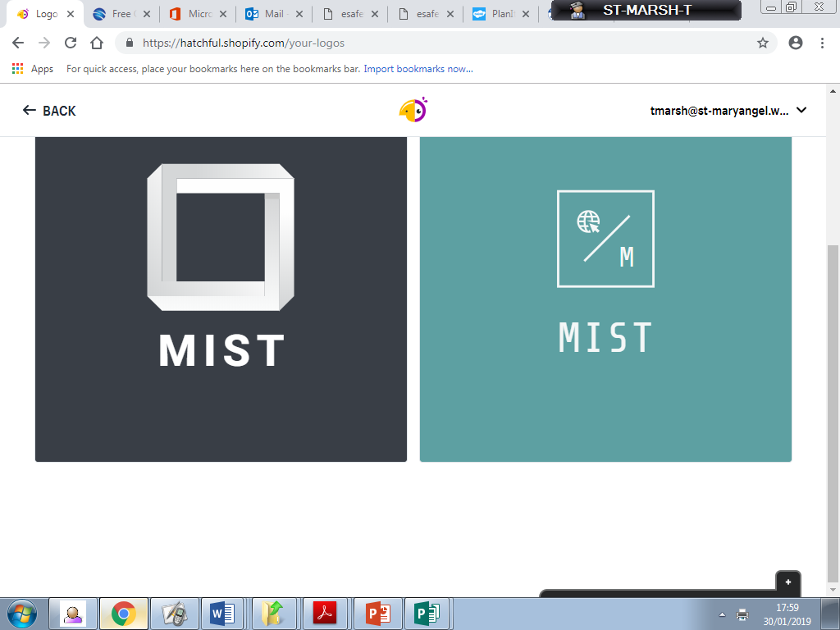

**Mary’s**

**Internet**

**Safety**

**Team**

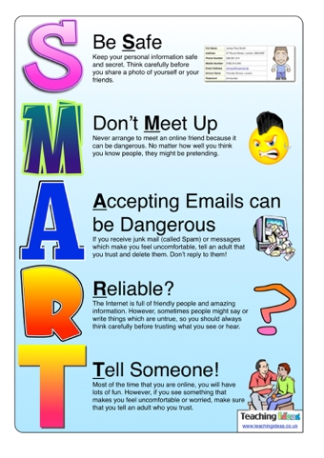

**Online Safety Questionnaire**

**Tomorrow, your child will have a questionnaire based on e-Safety in their bags. If you could please complete it and send it back. The results will be analysed by the MIST Team ad results will follow in the next newsletter.**

Welcome!

It gives us great pleasure to introduce the first edition of the MIST newsletter and the first of the new academic term. This half term, all children have been settling back in and completing induction activities. This has included lots of e-safety work!

**Induction Week Activities**

The induction process for the new school year looked particularly at e-Safety and keeping safe online. All class focused on a particular area:

Reception: Helpful adults

Y1: Our key information

Y2: Using a tablet safely

Y3: Digital footprints

Y4: Cyberbullying

Y5: Protecting our identities

Y6: Bullying and Cyberbullying

**Student Feedback from Induction Week**

**“I enjoyed learning about Smartie and how to keep him safe.”**

**“I remembered Buddy’s song and how it showed me who to ask for help.”**

**“I learnt that a record is kept of what I go on. I didn’t know that.”**

**“I know now what to do if someone is mean to me online.”**

**“I enjoyed learning about fraud and what is it. It’s helping me to keep my identify safer online now.”**

**“We looked at the similarities and differences between cyberbullying and real life bullying. It has made me more aware.”**

**Autumn E-Safety Newsletter 2019**