**Belonging Key Reflection**

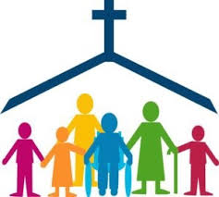

**What is the order of the Introductory Rite? Why is each part important?**

___________________________________________________________________________________________________________________________________________________________________________________________________________________________________________________________________________________________________________________________________________________________________________________________________________________________________________________

**Why do Christians believe that Mass is an important celebration?**

____________________________________________________________________________________________________________________________________________________________________________________________________________________________________________________________________________________________________________________________________

**What do Christians believe the oil of Chrism does during Baptism?**

______________________________________________________________________________________________________________________________________________________________________________________________________________________________________________________________________________________________________________________________________________________________

**Why is the sacrament of Baptism so important?**

____________________________________________________________________________________________________________________________________________________________________________________________________________________________________________________________________________________________________________________________________

**Key Vocabulary**

Belonging, Church, Sacrament, Confirmation,

Mass, Reconciliation, Anointing of the Sick.

Holy Orders, Marriage, Font, Water, Oil of

Chrism, White garment, Baptismal Candle,

Parents and Godparents.

**What are the signs and symbols of baptism and what do they mean?**

____________________________________________________________________________________________________________________________________________________________________________________________________________________________________________________________________________________________________________________________________