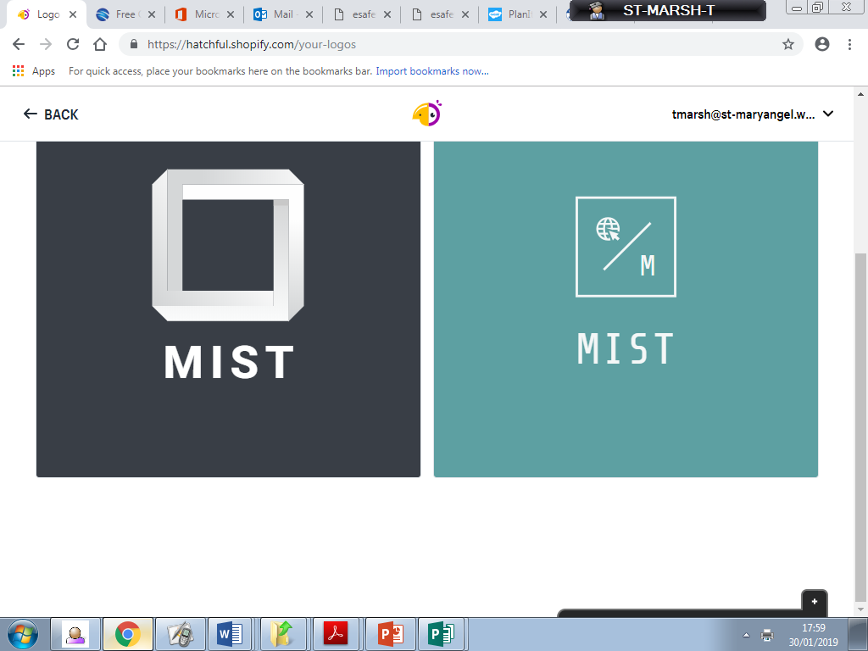

**Mary’s**

**Internet**

**Safety**

**Team**

Online Challenges and Peer Pressure

There are frequently online challenges that circulate on social media sites; many raise money or promote good causes such as the ‘Ice Bucket Challenge’. However, some of the challenges are more sinister and can entice users into daring, frightening and sometimes harmful activities. Children can be drawn into a challenge through peer pressure, thinking all their friends are completing the challenge so they themselves also need to do so. It can be hard to tell, at times, if such challenges are real or rumoured but it is important to have a conversation with your child about the importance of saying ‘no’ to pressure, even from friends, to complete inappropriate and risky challenges and the consequences of taking part in challenges, whether offline or online. Children need to report online content that is dangerous and encourages harm. Their first report needs to be to you.

Visit the ‘Parent Info’ website for examples of viral trends and suggested conversation starters that may help you.

https://parentinfo.org/article/viral-internet-trends-a-parents-guide

**Safer Internet Day**

Safer Internet Day 2019 will be celebrated on Tuesday 5th February 2019 with the slogan “Together for a better internet”. The day provides a fantastic opportunity to engage with children and find out about their digital lives. To help you talk to your children about having a positive and safe time online, the UK Safer Internet Centre has created a pack for parents and carers. including conversation starters, a factsheet, family pledge card and lots more.

https://www.saferinternet.org.uk/safer-internet-day/safer-internet-day-2019/education-packs/activities-parents-and-carers.

**Digital wellbeing**

Young people are growing up in a technological age that brings exciting online opportunities and experiences but it can also bring challenges. It is important that children understand how to use technology in a safe way and appreciate that it can have both a positive and negative impact on their wellbeing. Childnet has produced guidance on how you as a parent/carer can support your child with their digital wellbeing.

Take a look at the Childnet guidance here:

https://www.childnet.com/parents-and-carers/hot-topics/digital-wellbeing

Welcome!

It gives me great pleasure to welcome you to the first edition of MIST’s e-safety newsletter. A team of dedicated Year 4 & 5 students have come together to form a new school group aimed at educating, sharing and monitoring any online safety concerns both at home and at school. I hope that you find the information valuable in this letter and those to follow.

**Winter E-Safety Newsletter 2019**