Autumn Term
Autumn 1  Marvellous Me  (SMATT 1) | 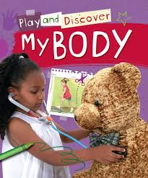  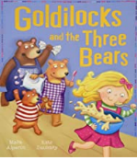  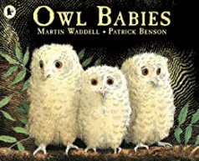 | Prime Areas  Learn and use new vocabulary. Share experiences, feelings and thoughts  Develop understanding of simple concepts, e.g. big/small & understand complex sentences. Play in a group and form special friendships  Communicate their need for the toilet. Separate from carer with support and encouragement. Adapt behaviour to different events and situations  Developing running (run safely; whole foot. Use climbing equipment. Kick, throw and catch a ball. Draw simple shapes. Develop control in pouring jugs & handling mark making tools.  Specific Areas  Literacy  Repeat & complete words or phrases from familiar stories and rhymes. Look at books independently and handle them carefully and turn pages. Join in with ‘Twinkl Phonics’ to begin to recognise different sounds and learn the songs and actions linked with the grapheme. Develop good listening skills through Phonics. Make marks and distinguish between these. Begin to understand that writing means something.  Maths  Begin to represent numbers using fingers, marks on paper or pictures. Select a small number of objects from a group when asked. Recite some number names in sequence by singing different number songs and joining in with actions. Find out how we change an amount by adding or taking away practically. Observe images and models and be encouraged to notice simple shapes and patterns. Begin to categorise objects according to properties such as shape or size. Begin to understand some talk about immediate past and future, e.g.’ before’, ‘later’ or ‘soon’. Anticipate specific time-based events such as mealtimes or home time and begin to order these.  UTW & EAD  Play with small-world models and take part in role play activities. Learn to have a sense of own immediate family & relations. Learn to imitate everyday actions and events from own family  Notice differences between people. Join in with singing favourite songs. Create sounds by banging, shaking, tapping or blowing. Experiment with blocks, colours and marks and create representations | Active Learning: Participate in routines  Finding out and exploring  Being willing to ‘have a go’  Being involved and concentrating  Keep on trying  Enjoying achieving what they set out to do  Having their own ideas  Making links | Settling in to routines, expectations and establishing behaviour – rewards and sanctions.  Observing individual children, complete overviews.  Disney day
Autumn 2  Celebrations  (SMATT 5) | 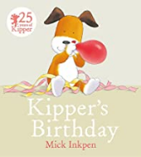 | Prime Areas  Notice and ask questions about differences between people. Develop friendships with other children, extending and elaborating play ideas. Express and manage their emotions. Follow rules. Grow in independence and only ask for help when needed. Develop their conversation with friends and adults and extend their vocabulary, using new vocabulary learnt in the setting. Use language to share feelings, experiences and thoughts. Listen to simple stories and understand what is happening, with the help of the pictures. Understand simple questions about ‘who’, ‘what’ and ‘where’, progressing to ‘why’. Respond to instructions. Develop their movement, balancing, riding (scooters, trikes and bikes) and ball skills. Skip, hop, stand on one leg and hold a pose for a game like musical statues. Use large-muscle movements to wave flags and streamers, paint and make marks. Meet their own care needs, e.g. brushing teeth, using the toilet, washing and drying their hands thoroughly and making healthy choices about food, drink and activities. Use one-handed tools and equipment, for example, making snips in paper with scissors and use a comfortable grip with good control when holding pens and pencils.  Specific Areas  Literacy  Begin to use some print and letter knowledge in their early writing, e.g. starting to write at the top of a page. Remember that writing and marks mean something. Introduced to the five key concepts about print: print has meaning, it can have different purposes, we read English text from left to right and from top to bottom, the names of the different parts of a book and page sequencing. Talk and ask questions about books and develop play around these. Join in with stories  Maths.  Develop fast recognition of up to 3 objects, without having to count them individually (‘subitising’). Recite numbers past 5 and say one number for each item in order: 1,2,3,4,5. Know that the last number reached when counting a small set of objects tells you how many there are in total (‘cardinal principle’). Talk about and explore 2D and 3D shapes, using informal and mathematical language: ‘sides’, ‘corners’, ‘straight’, ‘flat’, ‘round’. Make comparisons between objects. Talk about and identify the patterns around them; stripes on clothes, designs on rugs and wallpaper, using informal language like ‘pointy’, ‘spotty’, ‘blobs’. Describe a sequence of events, real or fictional, using words such as ‘first’, ‘then...’  UTW & EAD  Explore materials with different properties. Explore natural materials, indoors and outside. Show interest in different occupations. Explore and respond to different natural phenomena in their setting and on trips. Use all their senses in hands on exploration of natural materials. Express ideas and feelings through making marks, and sometimes give a meaning to the marks they make. Make simple models which express their ideas. | Active Learning: Participate in routines  Finding out and exploring  Being willing to ‘have a go’  Being involved and concentrating  Keep on trying  Enjoying achieving what they set out to do  Having their own ideas  Making links
Spring Term
Spring 1  Enchanted Worlds  Once upon a time…  (SMATT 2) | 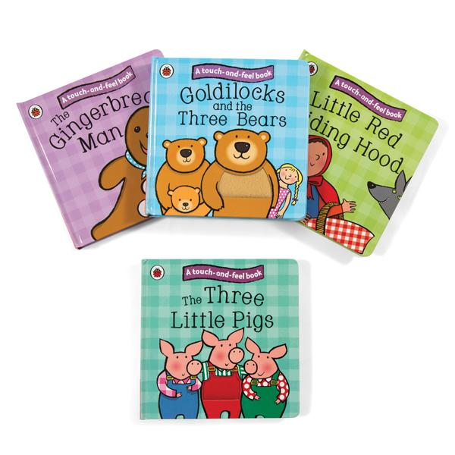  Traditional tales- children interest.  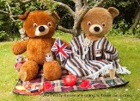 | Prime areas  Express feelings and that of others. Build constructive and respectful relationships. Think about the perspectives of others. Identify and moderate their own feelings socially and emotionally. Begin to regulate behaviour. Show independence, resilience and perseverance in the face of challenge. Explain the reasons for rules, ⎫ Connect and share ideas to another using a range of connectives responding to what they hear with relevant questions, comments and actions. Use new vocabulary through the day. Ask questions to find out more. Engage in story times Listen to and talk about stories to build familiarity and understanding. Retell the story. Combine different movements. Confidently and safely use a range of large and small apparatus indoors and outside. Develop overall body-strength, balance, co-ordination and agility. Develop a range of ball skills. Become more aware of different factors that support health and wellbeing. Develop small motor skills so that they can use a range of tools competently, safely and confidently. Develop the foundations of a handwriting.  Specific areas-  Literacy  Read individual letters by saying the sounds for them. Read some letter groups that each represent one sound and say sounds for them. Read a few common exception words. Re-read books to build confidence in word reading. Anticipate and recall key events in stories. Use and understand recently introduced vocabulary during discussions about stories, non-fiction, rhymes and poems and during role-play. Form lowercase and capital letters correctly. Spell words by identifying the sounds and then writing the sound with letter/s. Write short sentences with words with known sound-letter correspondences.  Maths  Count objects, actions and sounds. Count beyond ten. Compare numbers. Understand the ‘one more than/one less than’ relationship between consecutive numbers. Explore the composition of numbers to 10. Subitise (recognise quantities without counting) up to 5. Compose and decompose shapes so that children recognise a shape can have other shapes within it, just as numbers can. Continue copy and create repeating patterns. Compare length, weight and capacity.  UTW & EAD  Use our local environment to support their learning such as looking at types of homes, what they can see out of their window and different occupations we see in and around school. Develop positive attitudes about the differences between people. Plant seeds and care for growing plants. Understand the key features of the life cycle of a plant and an animal. Respect and care for the natural environment and all living things. Explore and talk about different forces they can feel and talk about the differences between materials and changes they notice. Explore different materials freely, in order to develop their ideas about how to use them and what to make. Join different materials and explore different textures. Make imaginative and complex ‘small worlds’ in line with their enchanted world’s topic.  Begin to show different emotions in their drawings and paintings, like happiness, sadness, fear etc. | Active Learning: Participate in routines  Finding out and exploring  Being willing to ‘have a go’  Being involved and concentrating  Keep on trying  Enjoying achieving what they set out to do  Having their own ideas  Making links  Choosing ways to do things | Walk around the local area – looking at houses
Spring 2  Enchanted worlds  Our Locality  (SMATT 4) | 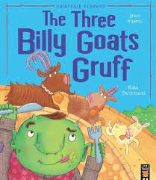  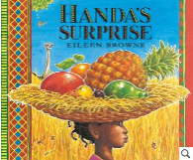  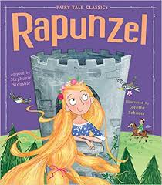 | Prime areas  Notice and ask questions about differences between people. Develop their ability to discuss and share their feelings and work with others to talk about and resolve conflict, in an appropriate way. Develop their understanding of rules and why it is important to follow these, without needing a reminder. Use a wider range of vocabulary. Know many rhymes and be able to talk about familiar books. Enjoy listening to longer stories and be able to retell much of what has happened. Respond to instructions. Use longer sentences and begin to express a point of view, debating when they disagree with their friends. Develop their movement, balancing, riding and ball skills. Improve their technique and control when they skip, hop, stand on one leg and hold a pose for a game like musical statues. Start taking part in some group activities, which they make up for themselves, or in teams. Be increasingly able to use and remember sequences and patterns of movements, which are related to music and rhythm. Be increasingly independent in meeting their own care needs. Use one-handed tools and equipment, for example, making snips in paper with scissors. Use a comfortable grip with good control when holding pens and pencils. Start to eat independently.  Specific Areas  Literacy  Begin to write their full name. Use some of their print and letter knowledge in their early writing. Begin to form some letters correctly. Explore traditional tales, such as Rapunzel and The Three Billy Goats Gruff. Develop their understanding of the five key concepts about print: print has meaning, it can have different purposes, we read English text from left to right and from top to bottom, the names of the different parts of a book and page sequencing. Talk and ask questions about books and develop play around these, engaging in extended conversations about this. Develop phonological awareness, so that they can begin to spot and suggest rhymes, count or clap syllables in a word, and recognise words with the same initial sound.  Maths  Match numerals and amounts: up to 5. Experiment with their own symbols and marks as well as numerals. Make comparisons between objects, such as length and capacity. Talk about and explore 2D and 3D shapes, using mathematical language. Select shapes appropriately, e.g. flat surfaces for building and combine shapes to make new ones. Begin to solve real world mathematical problems, such as addition and subtraction..  Compare quantities and use the correct language to do this, e.g. “more than; fewer than”.  UTW & EAD  Make sense of their own history. Know that there are different countries in the world and talk about this, sharing experiences and knowledge. Explore and think about buildings and materials, and how these have changed over time, e.g. materials used to build castles and houses in the past. ⎫ Continue to develop their drawing skills, focusing on detail and complexity. ⎫ Respond to what they hear, such as music from the past, and express their feelings towards this. ⎫ Learn old and current songs and sing the melodic shape of familiar songs. Begin to play instruments with increasing control, thinking about instruments old and new. ⎫ Begin to show different emotions in their drawings and paintings, like happiness, sadness, fear etc. | Active Learning: Participate in routines  Finding out and exploring  Being willing to ‘have a go’  Being involved and concentrating  Keep on trying  Enjoying achieving what they set out to do  Having their own ideas  Making links  Choosing ways to do things
Summer Term

Summer 1  Where are we going, how shall we get there?  Transport & Places  (SMATT 3) | 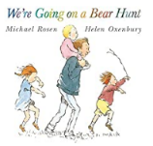  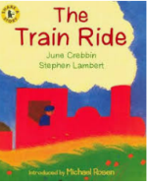  Nursey rhymes- linked with travelling; wheels on the bus/ Daisy Daisy/Noah’s ark  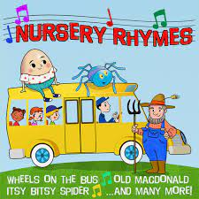 | Prime areas  Learn and use new vocabulary. Work together to achieve a goal, e.g. building a model vehicle. Begin to ask questions, notice differences & make comments. Retell a long story. Move with increased control & balance. Use a comfortable grip when holding pens and pencils. Demonstrate increased independence when selecting and using resources. Listen to and join in with songs and stories. Follow instructions. Show a preference for a dominant hand.  Specific areas  Literacy  Use print and letter knowledge in their writing. Join in with stories, songs and rhymes. Engage in conversation about the stories they have read and incorporate this into their play. Develop phonological awareness, so that they can: spot and suggest rhymes, count or clap syllables in a word & recognise words with the same initial sound.  Maths  Count, recite and link numerals to amounts. Solve mathematical problems. Discuss routes, maps & locations. Name, describe and select shapes appropriately. E.g. flat surfaces to build.  UTW & EAD  Develop positive attitudes about the differences between people. & know that there are different countries in the world, discussing the differences they have experienced or seen in photos. Talk about how things work. Explore and create using materials. Use instruments with increasing control | Active Learning: Participate in routines  Finding out and exploring  Being willing to ‘have a go’  Being involved and concentrating  Keep on trying  Enjoying achieving what they set out to do  Having their own ideas  Making links Choosing ways to do things
Summer 2  Summer  (SMATT 1) | 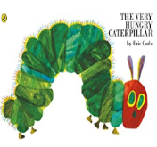  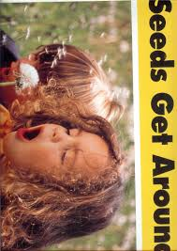 | Prime areas  Discuss differences, such as skin colour, types of hair, gender, special needs and disabilities. Help to find solutions to conflicts. Begin to understand how others might be feeling. Begin to follow rules without being prompted. Develop appropriate ways of being assertive. Select and use activities and resources with help when needed. Show more confidence in new social situations. Understanding why rules are important. Enjoy listening to longer stories and remember much of what happens. Follow a two - part instruction. Answer why questions. Use a wide range of vocabulary. Begin to use correct tenses and plurals. Begin to discuss and explain their ideas. Use talk to organise themselves and their play. Talk about stories. Develop skills in performing movements such as running, balancing, climbing and use simple techniques when playing games; stopping, changing direction, moving into a space. Use and remember sequences and patterns of movements which are related to music and rhythm. Start taking part in some group activities. Be increasingly independent in meeting their own care needs. Begin to recognise healthy choices. Use one-handed tools and equipment, for example, making snips in paper with scissors. Use a comfortable grip with good control when holding pens and pencils. Begin to be more independent in dressing and undressing themselves  Specific areas  Literacy  Use some print and letter knowledge in early writing. Begin to write for a purpose; letter, list, label. Write name with some letters being correctly formed. Understand the five key concepts about print: Listen for the sounds that can be heard in words and orally blend. Recognise some initial sounds and their corresponding grapheme. Develop play around favourite stories using props. Repeat words and phrases from familiar stories and rhymes.  Number  Working with numbers up to 5 and then 10, children will: recite numbers, count and Understand the value objects/amounts accurately. Begin to solve problems and understand some vocabulary including comparing amounts. Explore 2D and 3D shapes; discuss and describe position & location. Talk about, create & correct patterns; compare objects (size, length, weight, capacity)  UTW & EAD  Understand their own history (personal/family) Develop a positive attitude towards differences between people (occupation, gender, ethnicity, culture.) & places (countries). Explore materials and their properties; make observations and give explanations; show an interest in caring for the environment and living things. | Active Learning: Participate in routines  Finding out and exploring  Being willing to ‘have a go’  Being involved and concentrating  Keep on trying  Enjoying achieving what they set out to do  Having their own ideas Making links  Choosing ways to do things | Sowing seeds  EYFS Trip

