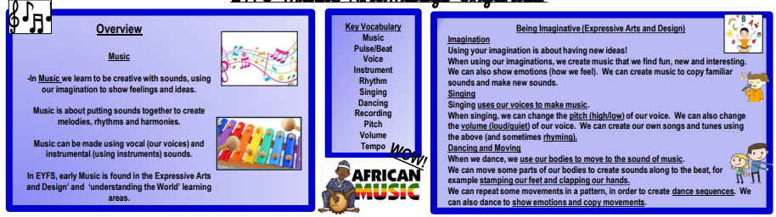

Familiar Songs - Familiar Songs are songs we know well. They include:

Nursery Rhymes, Happy Birthday song, Hymns, Christmas Carols, Theme Tunes, Simple Pop songs.

Instruments - Musical instruments are objects that are used to make music. Musical instruments can be made out of many objects, e.g. spoons, pans, tumblers and boxes.

Some Instruments Are - Drums, Xylophone, Maracas, Triangle, Cymbals, Tambourine, Guitar, Piano, Keyboard, Harp, Violin, Recorder, Harmonica, Bell, Trumpet

Body Percussion – We can make music by hitting different parts of our bodies together. Some examples are: clapping our hands, patting our knees, stamping our feet, clicking our fingers. Can you think of any more?