Key Reflection Sheet
Reception Unit A: Creation
Name some parts of God’s creation.

What gifts did God give you?

Where can you read about God’s creation? | 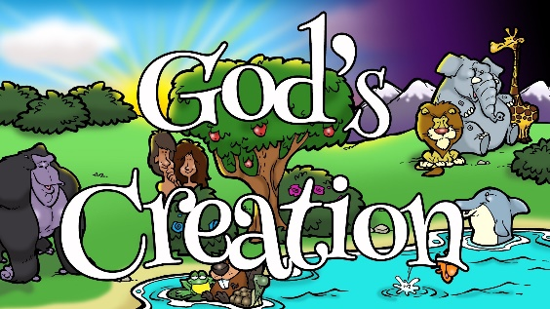  V O C A B U L A R Y  Bible,  God,  creation,  gifts.

