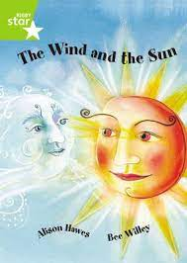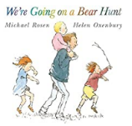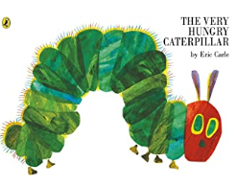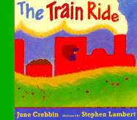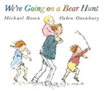



***Plot***

A lovely retelling of Aesop’s fable about who is stronger; the sun or the wind.

***Author***

Alison Hawes

***Characters***

The wind and the sun

***Key vocabulary, phrases & questions***

* Strong, stronger, strongest
* Fable – what does this mean?

Who do you think will win?

Why did the man take off his coat?

Have you ever been to a hot place/country?

Pack a suitcase for a summer holiday.

How do we protect ourselves when it is hot?

***Plot***

This book tells the story of a caterpillar who is very hungry. He eats his way through lots of different food, before finally emerging as a butterfly.

***Author***

Eric Carle

***Characters***

The Very Hungry Caterpillar

***Key vocabulary, phrases & questions***

* But, he was still hungry (repeated)
* The days of the week (can you order these?)
* Cocoon

Is this food healthy? Do you eat healthily?

Where does fruit come from?

What would you pack for a picnic? Where could we go for a picnic?

What happens to our caterpillars? (We will be housing our own caterpillars in Nursery)

Role play opportunity – Farm

***Plot***

Follow and join in the family's excitement as they wade through the grass, splash through the river and squelch through the mud in search of a bear. What a surprise awaits them in the cave on the other side of the dark forest!

***Author***

Michael Rosen

***Characters***

A family

***Key vocabulary, phrases & questions***

* We’re going on a bear hunt, we’re going to catch a big one… (Repeated)
* Oozy; squelch
* Swirling; whirling

Where can we find squelchy mud/long grass?

Can you join in with the repeated parts?

Can you use instruments to accompany the story?

Can you think of other ways to travel through these settings?

***Plot***

limb aboard for a rhythmic train ride through the country. There's lots to see and someone very special waiting at the end!

***Author***

June Crebbin

***Characters***

Little girl, Mum

***Key vocabulary, phrases & questions***

* What shall I see? (Repeated)
* That’s what I see… (Repeated)
* Journey
* Town
* Mare; foal
* A gaggle of geese

Have you ever been on a train?

What other transport can you think of?

Where do you think they are going?

Who do you think they will meet?

Role play opportunity – Train Station