 |  | Autumn 1 | Autumn 2 | Spring 1 | Spring 2 | Summer 1 | Summer 2
Nursery | FiCTION | Theme: Marvellous Me  Owl Babies – Martin Wadell  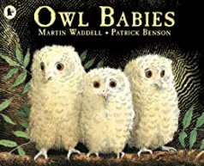  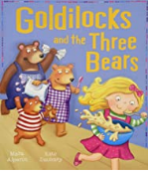  Goldilocks and the three bears | Theme: Celebrations  Kipper’s Birthday – Mick Inkpen  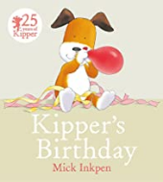 | Theme: Enchanted Worlds (Traditional Tales)  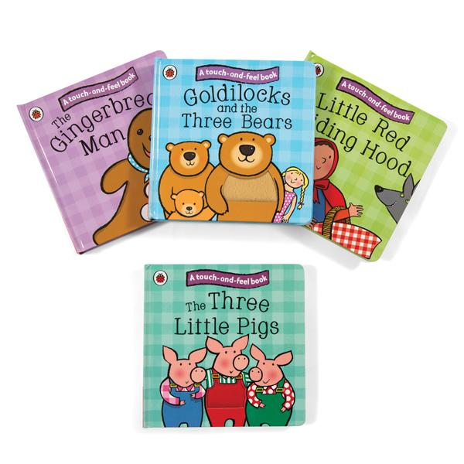  Three pigs /Jack & the Beanstalk. | Theme: Enchanted Worlds (Our environment)  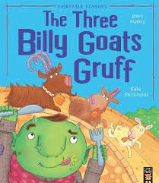  Three billy goats  gruff  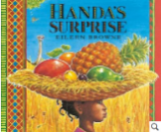  Handa’s Surprise – Eileen Browne  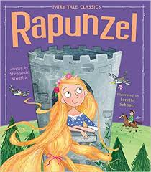  Rapunzel | Theme: Where are we going, How shall we get there? (Travelling)  Little red riding Hood  We’re going on a bear Hunt –Michael  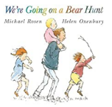  l Rosen  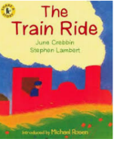  The train ride – June Crebbin | Theme: Where are we going, How shall we get there? (Summer)  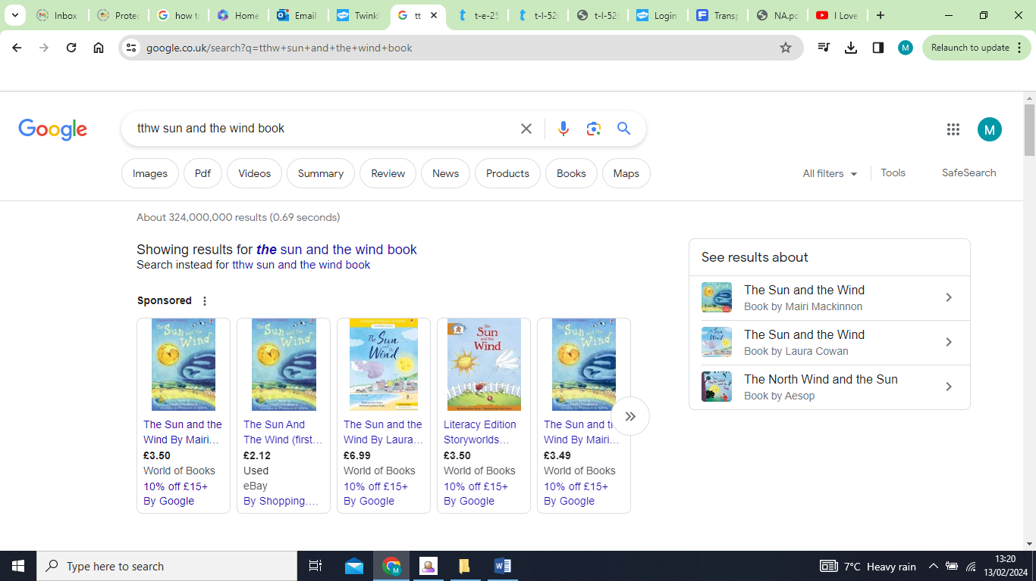  Traditional tale – Wind & the Sun  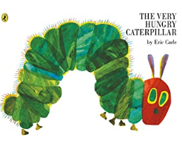  The Very Hungry Caterpillar – Eric Carle
 | POETRY | Traditional Nursery Rhymes | “Happy Birthday” song | 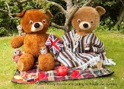  If you go down to the woods today |  | Nursey rhymes- wheels on the bus/ Daisy Daisy/Noah’s ark | Nursery rhyme – Mary Mary, Quite contrary
 | Non-Fiction | 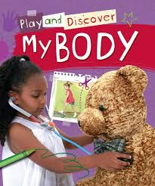  My body | 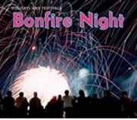  Bonfire night  Diwali |  | 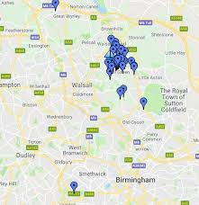  Maps/photographs of Aldridge |  | 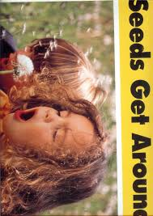  Seeds get around – a big book
 |  | Autumn 1 | Autumn 2 | Spring 1 | Spring 2 | Summer 1 | Summer 2
Reception | FICTION | Theme: Marvellous Me  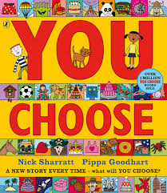  You choose – Nick Sharrat | Theme: Celebrations Significant Author: Julia Donaldson  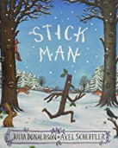  Stick Man – Julia Donaldson  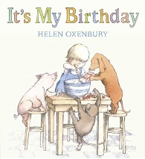 | Theme: Enchanted Worlds (The sea)  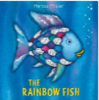  The Rainbow fish – Marcus Pfister  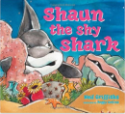  Shaun the Shy Shark –Neil Griffiths | Theme: Enchanted Worlds (Space)  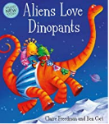  Aliens Love Underpants – Claire Freedman  Baboon on the moon  (literacy shed)  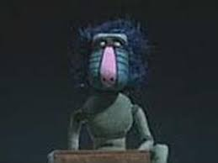 | Theme: Where are we going, How shall we get there? (Rainforest)  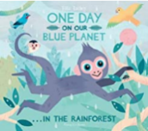  One Day on Our Blue Planet: In the Rainforest –Ella Bailey  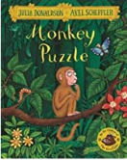  Monkey Puzzle – Julia Donaldson | Theme: Where are we going, How shall we get there? (Seaside)  Share the shell - Julia Donaldson  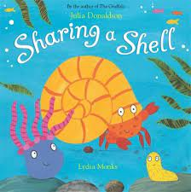  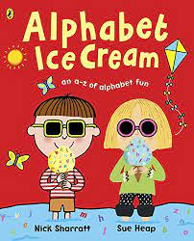  Alphabet Ice-cream -Nick  Sharrat & Sue Heap
 | Poetry | Rhymes linked with people who help us – Five fireman standing in a row…/ Miss Polly had a dolly… |  | 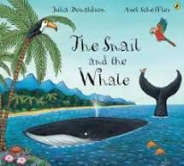  The snail and the whale – Julia Donaldson |  | The animal boogie  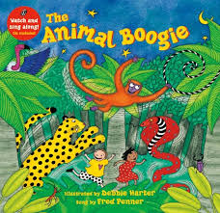 |   We’re all going on a summer holiday - song
 | Non-Fiction | My body – flip book  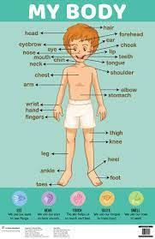 |  | Non fiction – One day on our blue planet  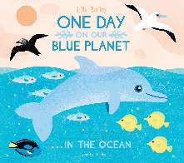 | Astronauts – Non fiction text  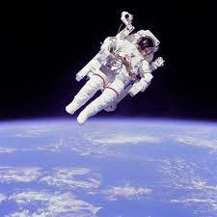 | 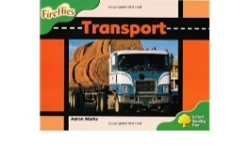  Transport – guided reading book
 |  | Autumn 1 | Autumn 2 | Spring 1 | Spring 2 | Summer 1 | Summer 2
Year 1 | FICTION | Theme – Family & Friends  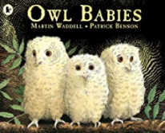  Owl Babies by Martin Waddel  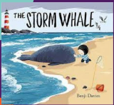  The Storm Whale by Benji Davies | Theme – Familiar Settings  Oliver’s Vegetables by Vivian French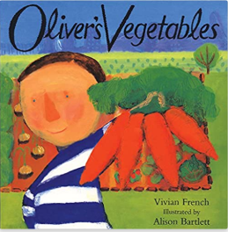  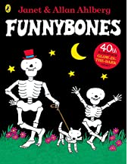  Funny Bones by Allan Ahlberg | Theme: Growing/ Traditional Tales  Enormous Turnip  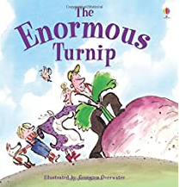  Jack and the Beanstalk  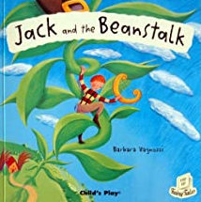 | Theme: Significant Author Jill Murphy  Whatever Next  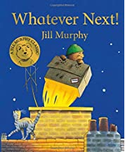  Peace at last  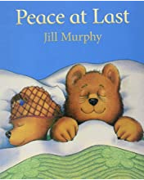  Five minutes Peace  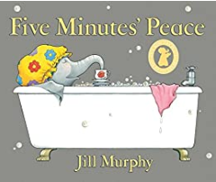 | Theme – Classic Texts  The Tiger that came to tea by Judith Kerr  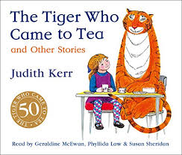  Mog and the VET  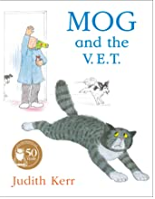 | Theme - Adventure  Traction Man – Mini Grey  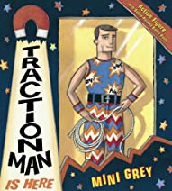
 | Poetry | 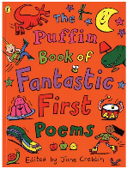  Pie Corbett,  A Book of Fantastic First Poems  Inside there are many sections including: families,  feelings, friends, pets, school) |  | 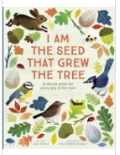  Poetry based on growing | Poetry based on space  https://www.teachprimary.com/resource_uploads/swing-on-a-star1.pdf | Riddles  I see a tiger :  http://poetryforkidsjoy.blogspot.com/2011/06/tiger-poem.html  The Dancing Tiger  By Malachy Doyle |  | Super hero songs and rhymes
 | Non-Fiction | 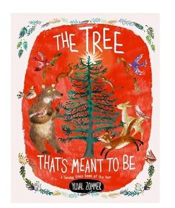  The Tree That’s Meant to Be | The Big Book of Beasts  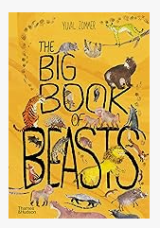 | 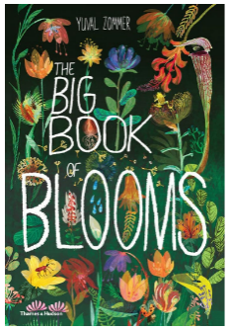  Yuval Zommer | Florence Nightingale  Coming to England- Floella Benjamin  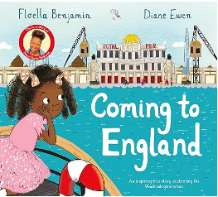 | Victorians  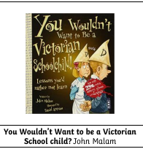 | The Big Book of Nature Nature  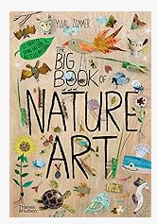
 |  | Autumn 1 | Autumn 2 | Spring 1 | Spring 2 | Summer 1 | Summer 2
Year 2 | FICTION | Theme – Wellbeing/Emotions  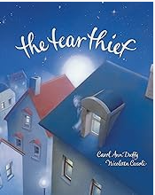  The Tear Thief by Carol Ann Duffy | 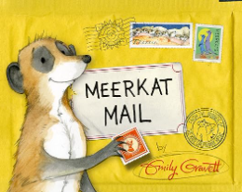  Theme – Travel  Meerkat Mail by Emily Gravett | Theme - Wellbeing  The Day The Crayons Quit - Drew Daywalt  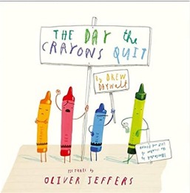 | Theme – Traditional Tales  Who’s afraid of the Big Bad Book? – Lauren Child  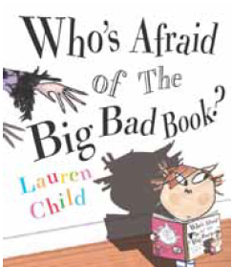 | Theme – Adventure  The Pirate Cruncher - Jonny Duddle  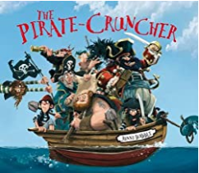 | Theme – The Seaside  Lighthouse Keeper’s Lunch - Ronda Armitage and David Armitage  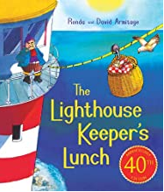
 | Poetry | Free Verse Poetry (Poetry Shed)  ‘Thought  Machine’ by Laura Mucha  https://lauramucha.com/  poetry/thought-machine/ | 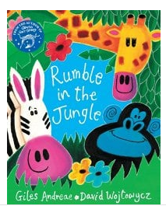 | The Crow’s Tale (poetry) | "The boy with the similar name" by Roger McGough | "The seagulls" by Michel Rosen | "Treasures on the beach" by Brenda Williams
 | Non-Fiction | Malala’s Magic Pencil by Malala Yousafzai  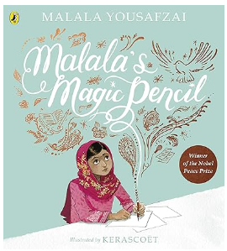 | 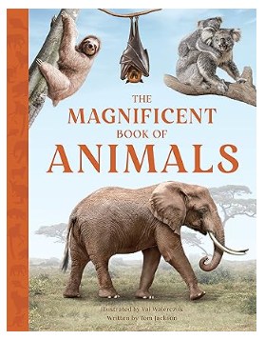 | 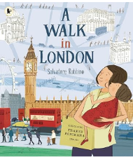  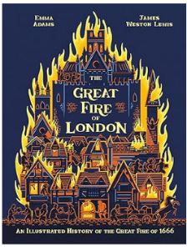  The Great Fire of London by Emma Adams  A walk in London by Salvatore Rubbino |  | 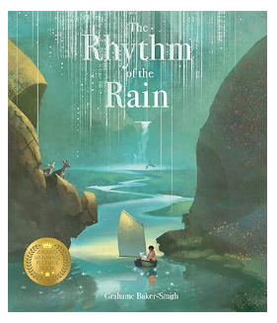 | 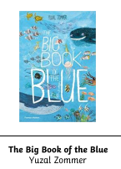

 |  | Autumn 1 | Autumn 2 | Spring 1 | Spring 2 | Summer 1 | Summer 2
Year 3 | FICTION | Theme – Alternative Traditional Tales  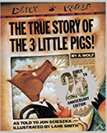  The True Story of The 3 Little Pigs! - Jon Scieszka  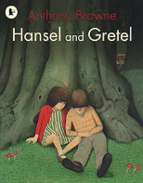  Hansel and Gretel by Anthony Browne | Theme – Historical  Stone Age Boy - Satoshi Kitamura  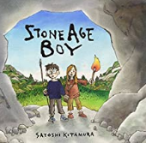  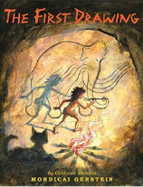  First Drawing by Mordicai Gerstein | Theme – Significant author: Dick King-Smith  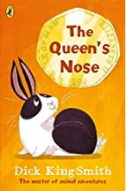  The Queen’s Nose – Dick King-Smith | 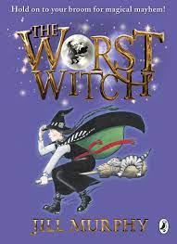  Theme – Jill murphy | 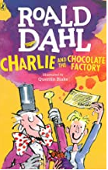  Theme - Chocolate  Charlie and the Chocolate Factory – Roald Dahl
 | POETRY | 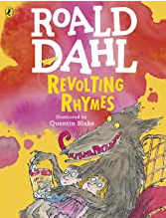  Humorous Poetry - Revolting Rhymes – Roald Dahl | Wordplay and humour – I was Born in the Stone Age by Michael Rosen | Poems from Around the World – Chinese Festival  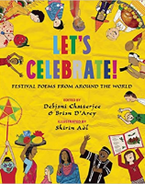  Let’s Celebrate! edited by Debjani Chatterjee and Brian D’arcy - The Chinese Dragon by Catherine Benson |  | 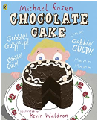  Performance Poetry
 | NON-FICTION | 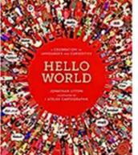  Information texts focusing on different parts of the world l | 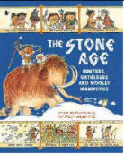  The Stone Age Hunters,  Gatherers and Woolly  Mammoths by Marcia  Williams | 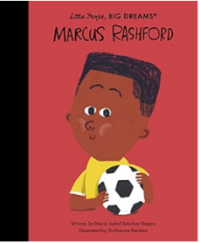 | 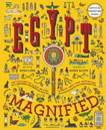  Egypt Magnified by  David Long | 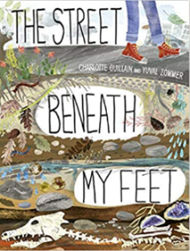

 |  | Autumn 1 | Autumn 2 | Spring 1 | Spring 2 | Summer 1 | Summer 2
Year 4 | FICTION | 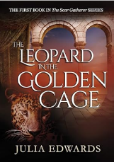  Theme – Legends & Historical Fiction  The Leopard in the Golden Cage By Julia Edwards |  | Theme – Fantasy – Vikings  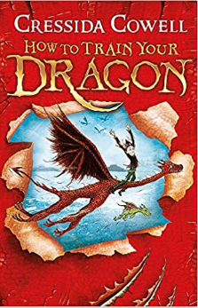  How to Train Your Dragon by Cressida Cowell |  | Theme – Significant Author: C.S Lewis  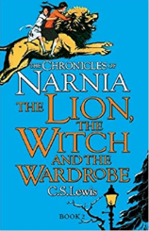  The Lion, The Witch and  The Wardrobe
 | POETRY | Image poetry  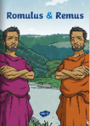  The Wolf and The Woodpecker (Linked to Romulus and Remus) | WW1 Poetry –  Where the poppies now grow by Hilary Robinson & Martin Impey,  Carol Ann Duffy: The Christmas Truce, In Flanders Field | List Poetry – Metaphors and similes  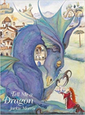  The Dragons inside of me- Pie Corbett.  Tell Me A Dragon Poem by Jackie Morris |  | 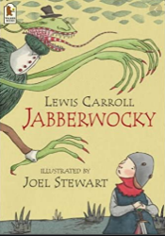  Classical Nonsense Poetry  The Jabberwocky  BY LEWIS CARROLL
 | NON-FICTION | Recount  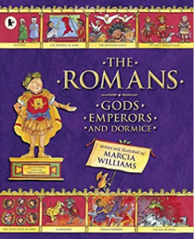  The Romans: Gods, Emperors and Dormice by Marcia Williams | Recount Biographies  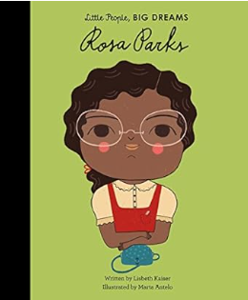  Rosa Parks | Inform/instruct  Dare to Care: Pet Dragon  by Mark Robertson  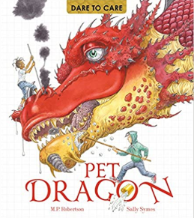 |  | Persuasive (Link with WLP Blue Planet)  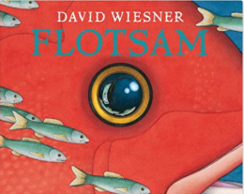  Flotsam by David Wieesner
 |  | Autumn 1 | Autumn 2 | Spring 1 | Spring 2 | Summer 1 | Summer 2
Year 5 | FICTION | Theme: Modern Classic - Crime and Punishment  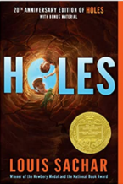  Holes by Louis Sachar |  | 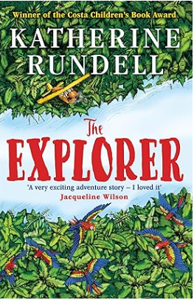  Theme: Adventure  The Explorer |  | Theme: Myths and Legends – Ancient Greeks  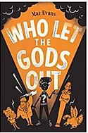  Who Let the Gods Out by Maz Evans
 | POETRY | Theme: Legends - Crime and Punishment  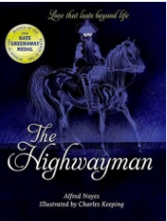  The Highway Man |  | 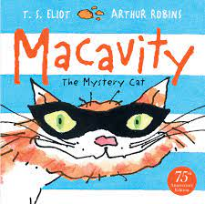  Classic Narrative Poetry  Mr McCavity- TS Elliot |  | Theme Poetry: Mythical Beasts  The Museum of Mythical Beasts by Brian Moses  A Plea From the Rescue Centre for Mythical Beasts by Brian Moses
 | NON-FICTION | 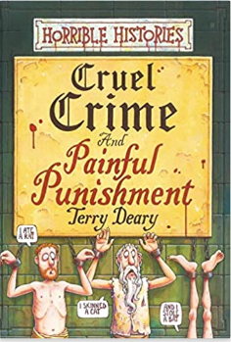 | 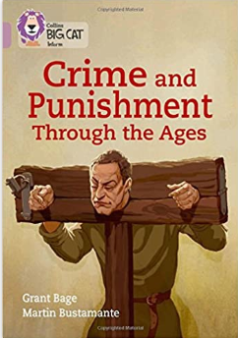 | 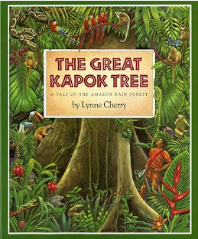 | Rainforest non-fiction  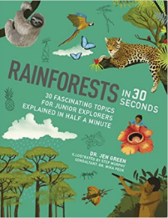 | 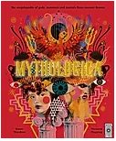  Mythologica: An Encyclopedia of Gods, Monsters and Mortals from Ancient Greece by Dr Stephen Kershaw & Victoria Topping  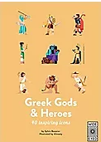  Greek Gods & Heroes by  Sylvie Baussier & Almasty

 |  | Autumn 1 | Autumn 2 | Spring 1 | Spring 2 | Summer 1 | Summer 2
Year 6 (set 2) | FICTION | Theme: Historical Mystery – WW2  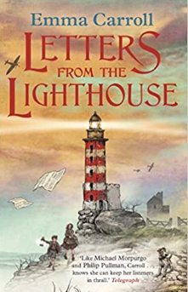  Letters From the Lighthouse by Emma Carroll |  | 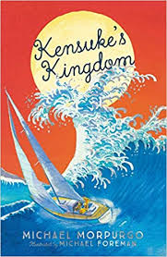  Theme: Adventure - Significant Author: Michael Murpurgo  Kensuke’s Kingdom by Michael Morpurgo |  | 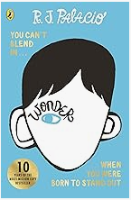  Theme: Inclusion  Wonder by R J Palacio
 | POETRY | 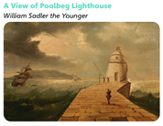 |  | Repetitive pattern poetry  Pie Corbett The Cave of Curiosity. https://soundcloud.com/talkforwriting/ city  Palindromic Poetry  Refugees by Brian Bilston https://brianbilston.com/2016/03/23/refugees/  https://www.youtube.com/watch?time_continue=98&v=eaMXn6Fkx2c |  | 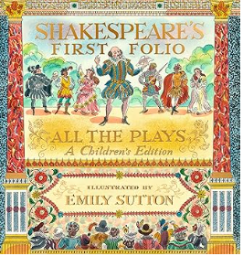  Narrative Poetry  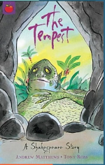
 | NON-FICTION | 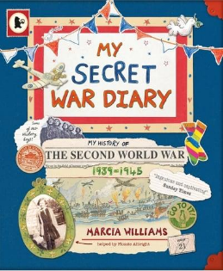  Recount (Diary and Letters)  My Secret War Diary by Marcia Williams, Information leaflets about evacuation and air raids |  | 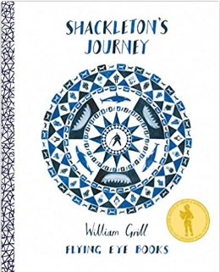  Persuasion Information/explanation (WLP link to polar regions)  Shackleton's Journey  by William Grill |  | 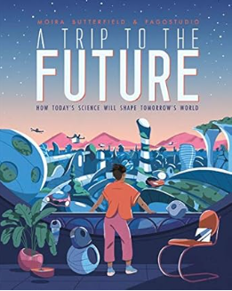  A Trip to the Future by Moira Batterfield

