**In the Mass what prayers are said to ask God for help ?**

____________________________________________________________________________________________________________________________________________________________________________________________________________________________________________________________________________________________________________________________________

**What different ways can we pray?**

____________________________________________________________________________________________________________________________________________________________________________________________________________________________________________________________________________________________________________________________________

**Key Vocabulary**

Prayer,

Cross, Candles, Church building, Blessed Sacrament, holy water, confession, statues, genuflection, sign of peace, sukkot, Psalm.

**Prayer Key Reflection**

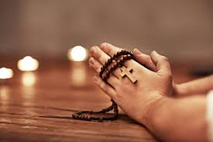

**Why was prayer so important for Jesus? How does this help us to understand the importance of prayer?**

___________________________________________________________________________________________________________________________________________________________________________________________________________________________________________________________________________________________________________________________________________________________________________________________________________________________________________________

**What symbols help us to pray?**

______________________________________________________________________________________________________________________________________________________________________________________________________________________________________________________________________________________________________________________________________________________________

**What gestures and actions are associated with prayer.?**

____________________________________________________________________________________________________________________________________________________________________________________________________________________________________________________________________________________________________________________________________