Useful adjectives (colours):

|  |  |  |
| --- | --- | --- |
| masculine | feminine | meaning |
| bleu | bleue | blue |
| blanc | blanche | white |
| rouge | rouge | red |
| noir | noire | black |
| jaune | jaune | yellow |
| gris | grise | grey |
| vert | verte | green |
| marron | marron | brown |
| orange | orange | orange |

Useful adjectives (other):

|  |  |  |
| --- | --- | --- |
| masculine | feminine | meaning |
| grand | grande | big |
| petit | petite | little |
| joli | jolie | pretty |
| jeune | jeune | young |

Useful verbs:

|  |  |  |
| --- | --- | --- |
| Singular (it) | Plural (they) | meaning |
| glisse | glissent | glides |
| regarde | regardent | looks at |
| brosse | brossent | brushes |
| joue | jouent | plays |
| dort | dorment | sleeps |
| marche | marchent | walks |

Year 6 Spring 1 KKO

Scène de Plage – Descriptive Writing

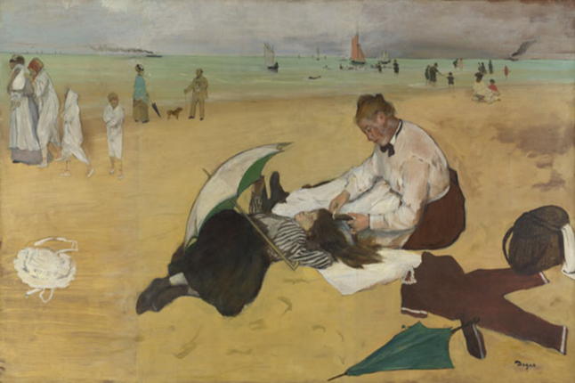

*Scène de Plage – Edgar Dégas (1869)*

Degas was born in France in 1834. He was well-educated and spent most of his life in Paris. He was studying to become a lawyer when he changed his mind and decided to train to become an artist. He liked to paint the modern world of the time, including racehorses and ballet dancers.

Types of sentences:

1. C’est un (or une)….. There is a …..

e.g. C’est une pelle verte. = There is a green spade.

1. Il y a un (or une) …. There is a …..

e.g. Il y a un sac marron. = There is a brown bag.

1. Le ___ est ____ . The ____ is ____.

e.g. La mer est bleue. = The sea is blue.

1. Le/la (noun) (verb) le/la (noun)

e.g. Le chien regarde la fille. = The dog looks at the girl.