Key Reflection Sheet
Reception Unit C: Advent
How many weeks is Advent? | How do we get ready for Jesus during Advent?
Say a prayer to Jesus asking him to help you to be ready.

What colour is the liturgical colour for Advent? | 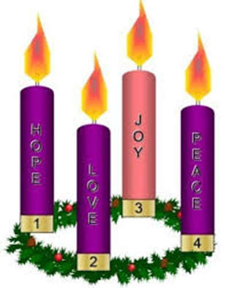  V O C A B U L A R Y  Advent,  waiting,  preparation

