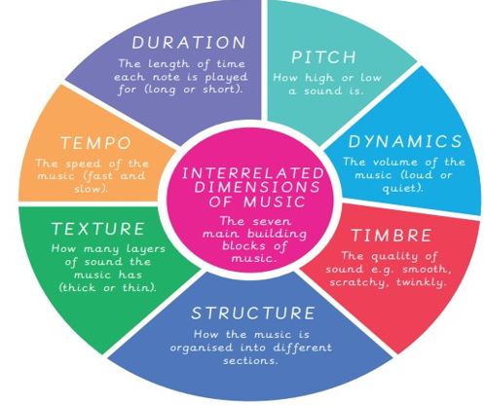 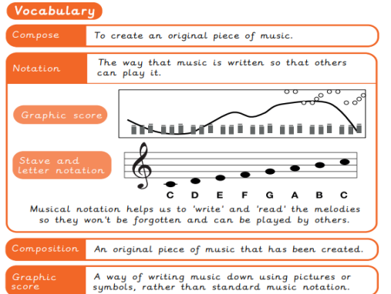

Year 4 Spring 1 KKO – Composing Through Art In collaboration with Walsall Music Hub and Walsall Art Gallery

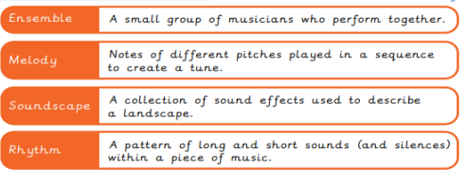

When creating your composition:

* Make sure you have planned the structure – beginning, middle and end.
* Rehearse your composition – check everyone knows what to do and when.
* Try to include contrast – e.g. change the dynamics or the tempo.